HALF ADDER

AIM: To perform half adder using logicism

INPUT:

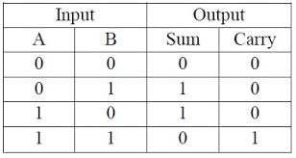

OUTPUT:

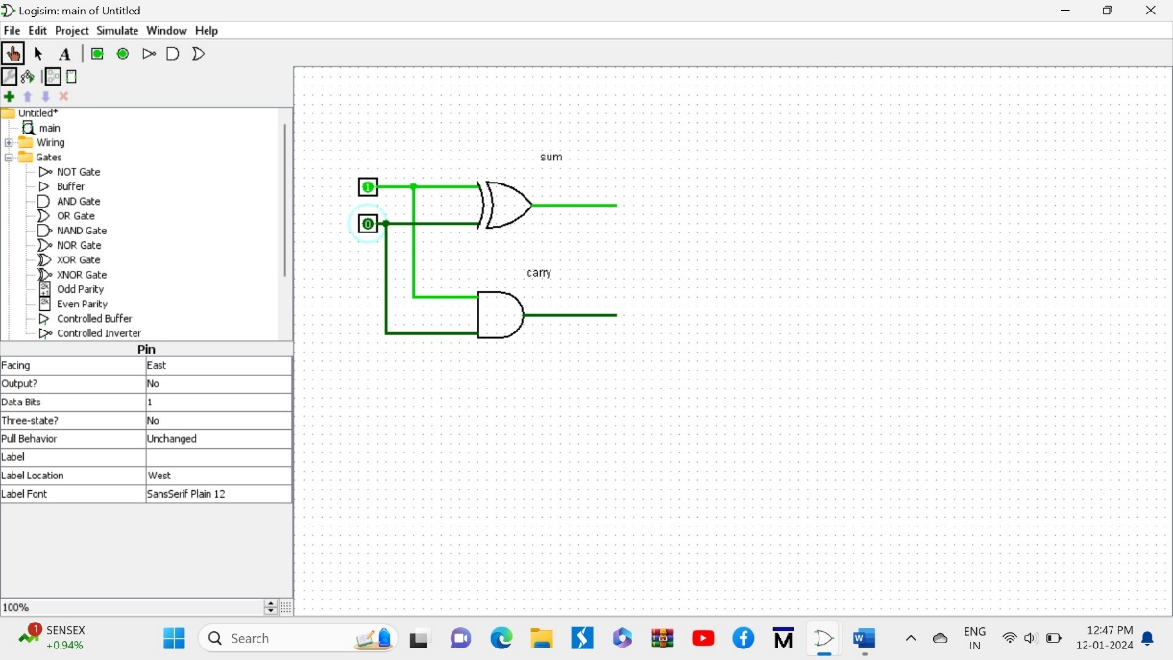

RESULT:

Half adder is successfully executed through logicism.